Experiment and result:

**Preparation test ---can be ignored**

batchsize=27 #batch size must be even  
iterations =10000  
hiddenunit = 30  
ita = 0.5  
keep_pro = 0.75

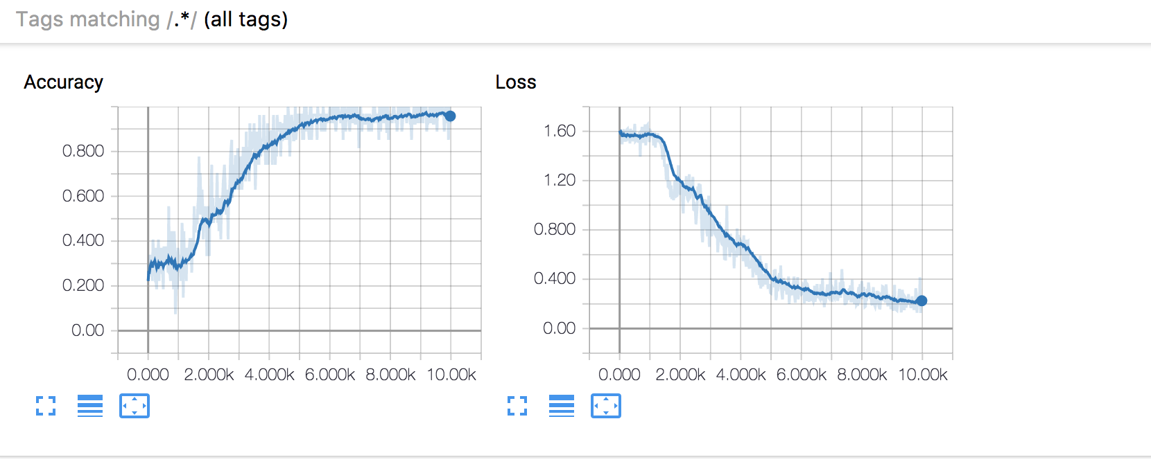

Accuracy:0.92 loss:0.22

batchsize=27 #batch size must be even  
iterations =15000  
hiddenunit = 30  
ita = 0.5  
keep_pro = 0.75

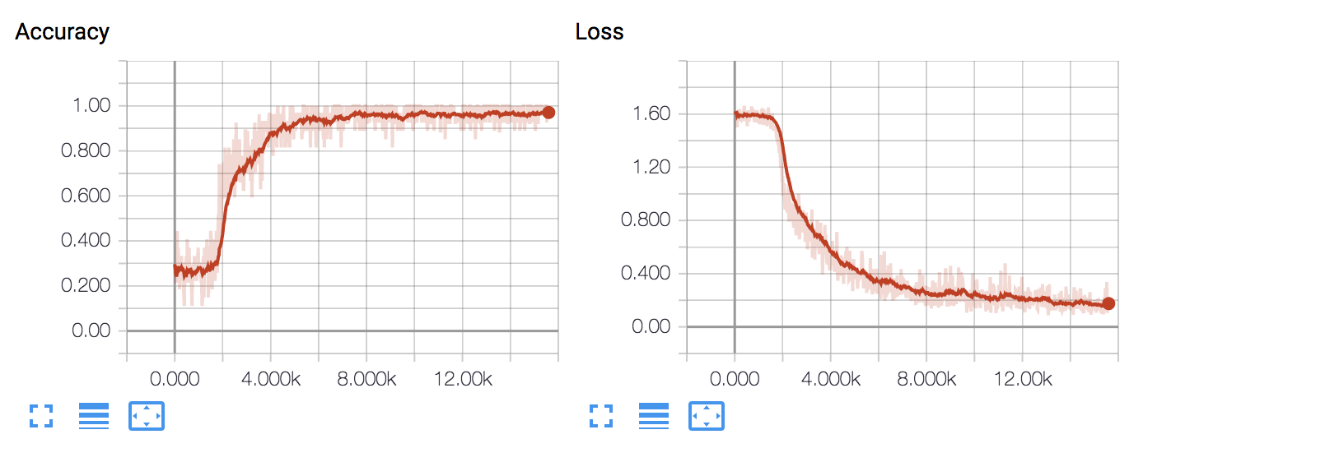

Accuracy:0.963 loss:0.18

## **1.Parameter adjustment:**

## 1.1 No shuffle result

1. Iteration

range: 30000,80000,5000

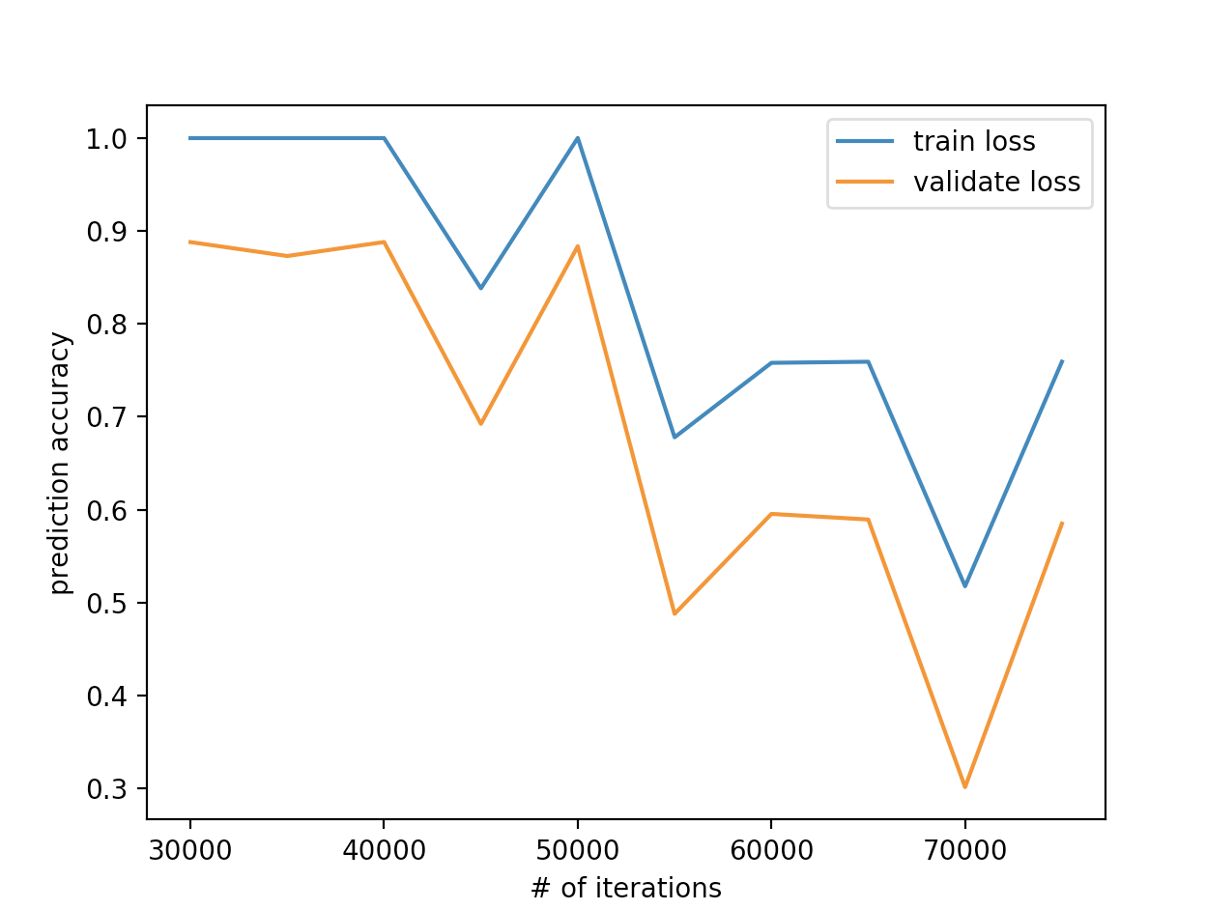

best iterations:40000

batchsize=27 #batch size must be even  
iterations =40000  
hiddenunit = 30  
ita = 0.5  
keep_pro = 0.75

**train accuracy:0.996656,test accuracy :0.597015**

**train accuracy:0.998328,test accuracy :0.820895**

**train accuracy:0.998328,test accuracy :0.731343**

**train accuracy:0.998328,test accuracy :0.895522**

**train accuracy:0.998328,test accuracy :0.955224**

**train accuracy:0.998331,test accuracy :0.939394**

**train accuracy:0.998331,test accuracy :0.969697**

**train accuracy:1.000000,test accuracy :0.984848**

**train accuracy:0.998331,test accuracy :0.984848**

**train accuracy:0.998331,test accuracy :0.984848**

**best iterations:40000**

**average test accuracy:0.886364**

**average train accuracy: 0.998 ---for cross validation set**

**k2 data as test data, result is shown as follow:**

**test data-k2 accuracy:0.612725(low)**

**if iteration =30000**

**test data-k2 accuracy:0.618257**

**if iteration =70000**

**test data-k2 accuracy:0.600277**

**if iteration = 8000**

**test data-k2 accuracy:0.659751**

**if iteration = 5000**

**test data-k2 accuracy:0.687414**

**When iteration =40000 the experiment results shown as follow:**

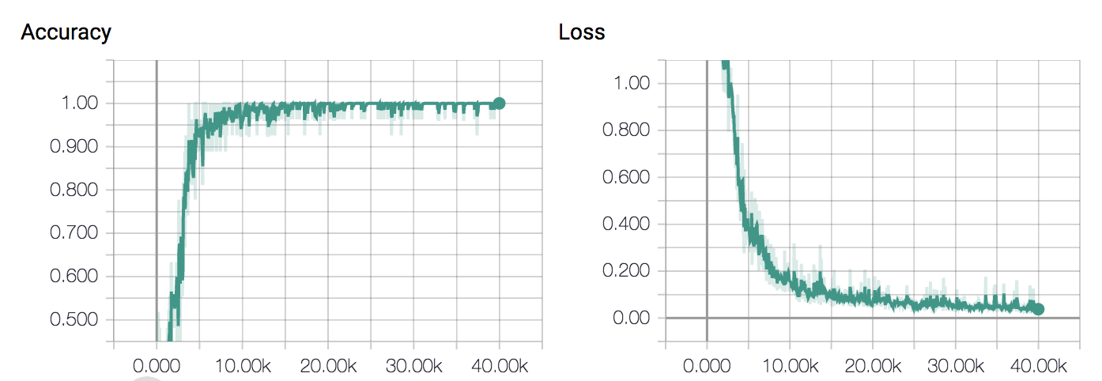

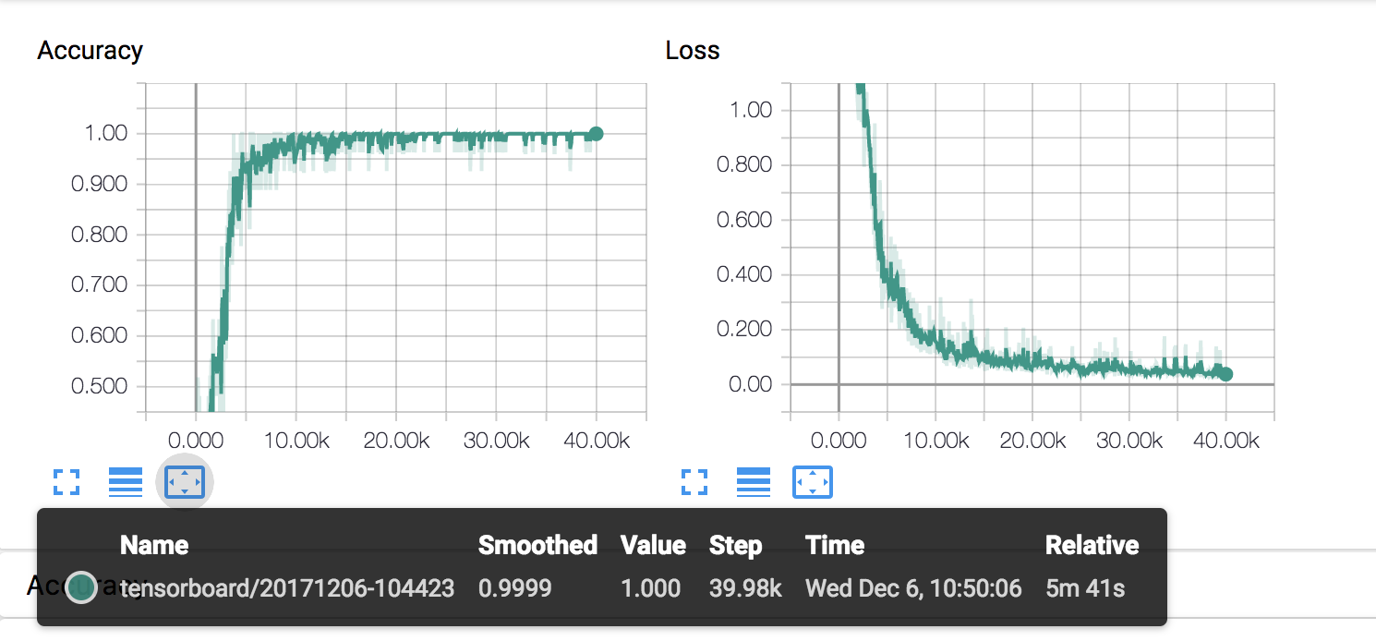

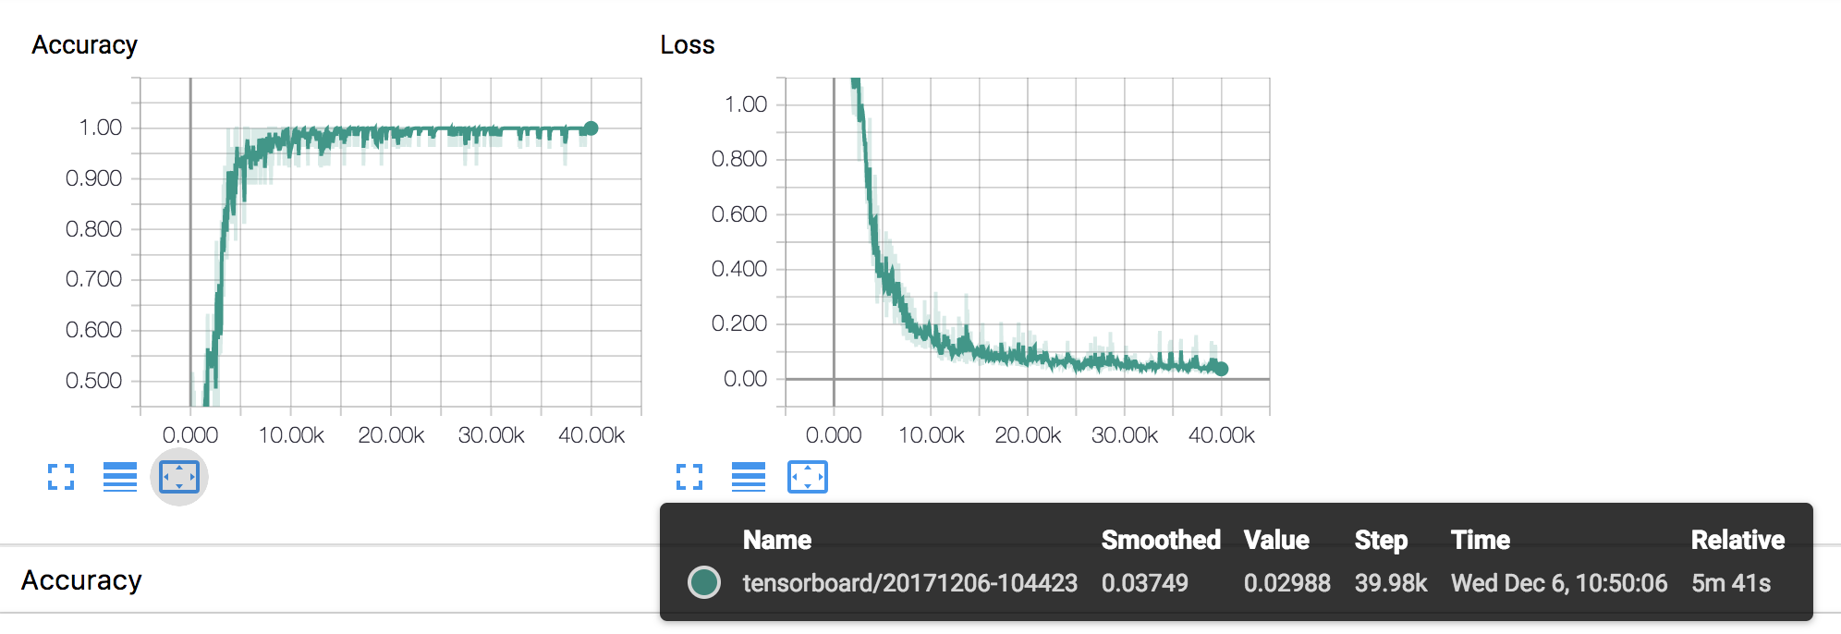

k-1 k-2 5000-50000

best iterations:35000 and max test accuracy:0.811381

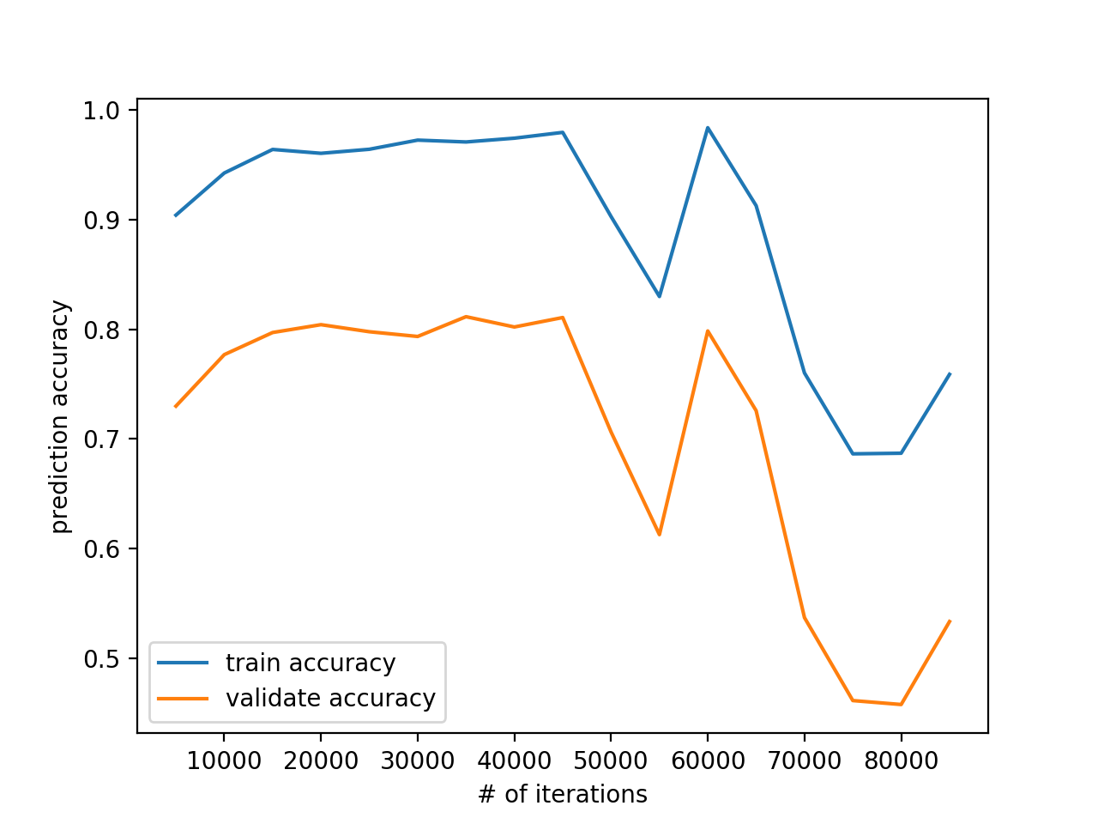

iteration =40000

if k-fold=4 validation accuracy is 0.61

if k-fold =7 validation accuracy is 0.630969

if k-fold =8 validation accuracy is :0.822852

if k-fold =9 validation accuracy is :0.803445

if k-fold =10 validation accuracy is 0.817099

if k-fold =12 validation accuracy is :0.832334

**Use the following test result**

**1. Neural network Classification**

(Shuffle cross validation)

Dataset :

## **A. Kinface-k1 and -k2 (**[**www.kinfacew.com)**](http://www.kinfacew.com))

We first use k1 as train dataset, k2 as test dataset. The accuracy of the k-2 dataset is 0.687414. This accuracy is limited. The reason is that k-1 contains 403 dataset, and k2 has 535 dataset. Train set have less dataset than test dataset. Generally, train dataset should be much more than the test dataset.

Therefore, we combine k1 and k2 as the training dataset.

k-fold: k=10

iteration=40000

train accuracy:0.935949,test accuracy :0.769784

train accuracy:0.967174,test accuracy :0.812950

train accuracy:0.973579,test accuracy :0.791367

train accuracy:0.982386,test accuracy :0.877698

train accuracy:0.985588,test accuracy :0.827338

train accuracy:0.979183,test accuracy :0.906475

train accuracy:0.983987,test accuracy :0.942446

train accuracy:0.985588,test accuracy :0.913669

train accuracy:0.984800,test accuracy :0.891304

train accuracy:0.989600,test accuracy :0.898551

best iterations:40000 and max test accuracy:0.863158

============================================

iteration 5000-90000

best iterations:70000 and max test accuracy:0.880440

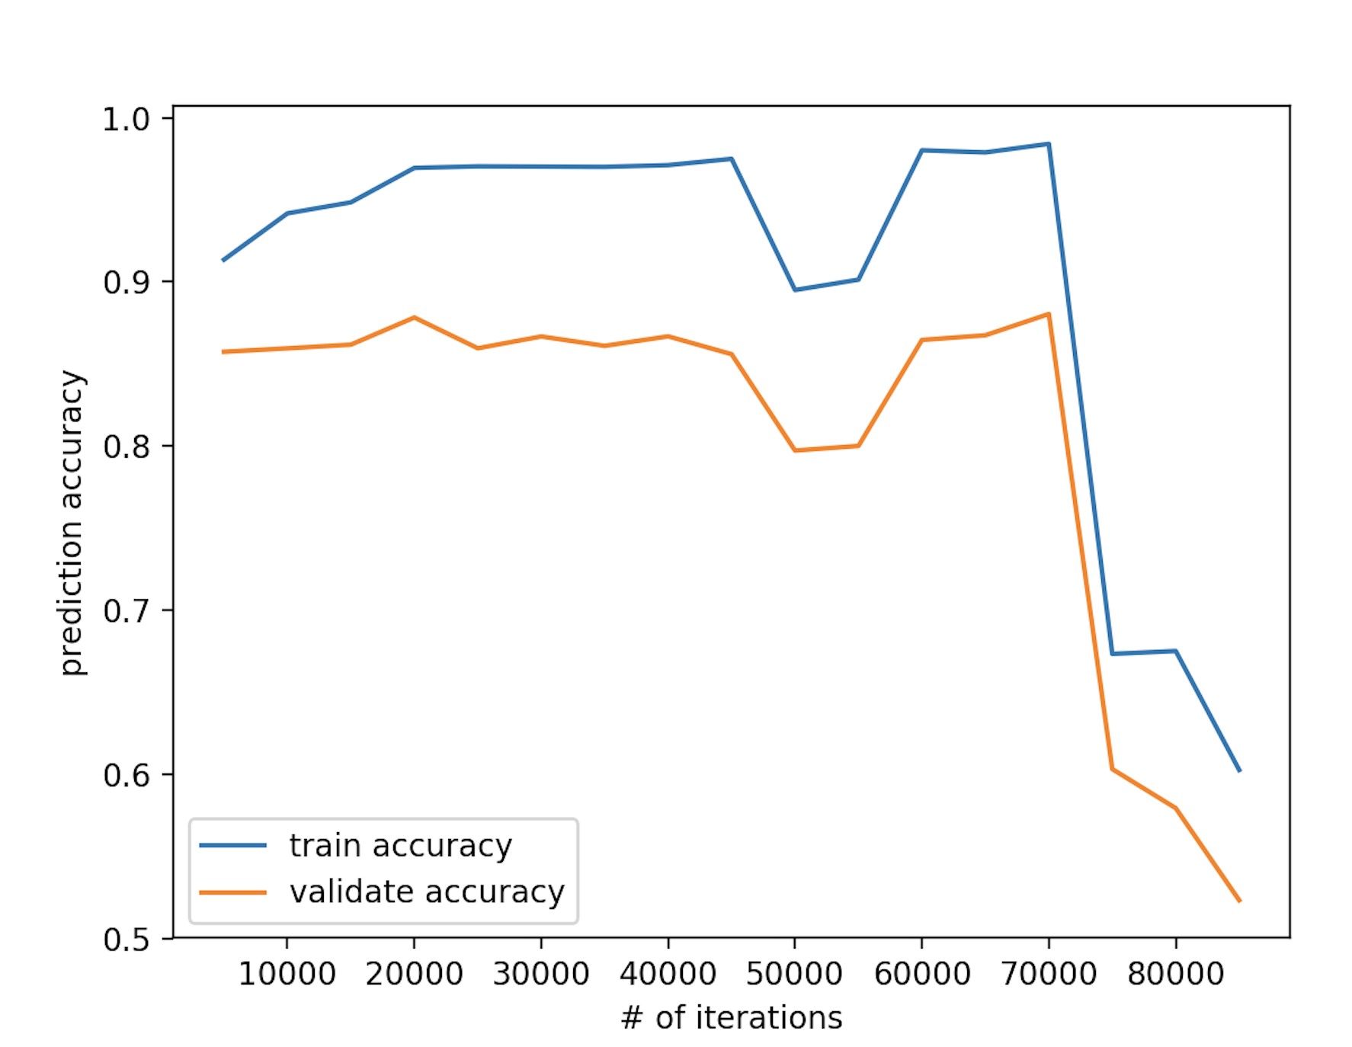

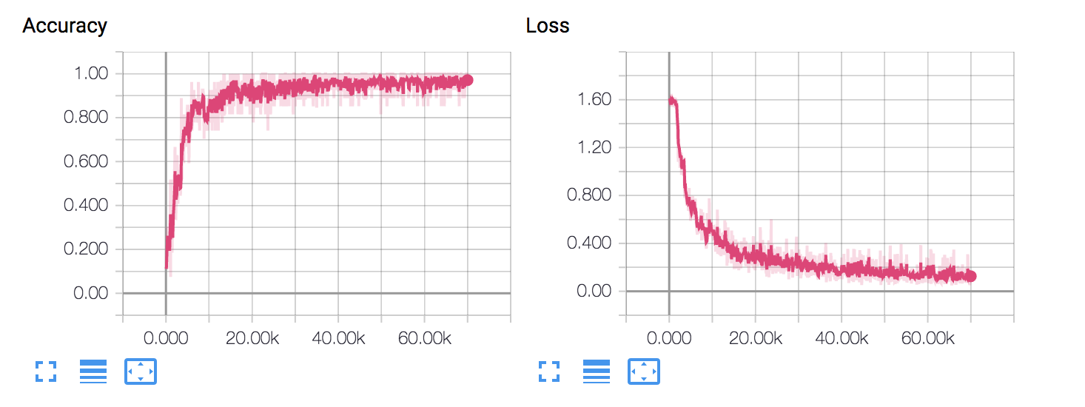

accuracy 0.9630 loss: 0.1447

whole train data accuracy:0.954611

iteration =70000

if k-fold=5 validation accuracy: 0.845132

if k-fold =6 validation accuracy is 0.834363

if k-fold =8 validation accuracy is ::0.762852

if k-fold =9 validation accuracy is : 0.798985

if k-fold =10 validation accuracy is 0.954611

B. Smile-fiw dataset(**<http://smile-fiw.weebly.com/download.html)-new> 5000 dataset**

Train

We use Simle-fiw as training dataset, kinface-k1 and k2 as test dataset, the result is shown as follow:

1) iterations_set =np.arange(5000,90000,10000)

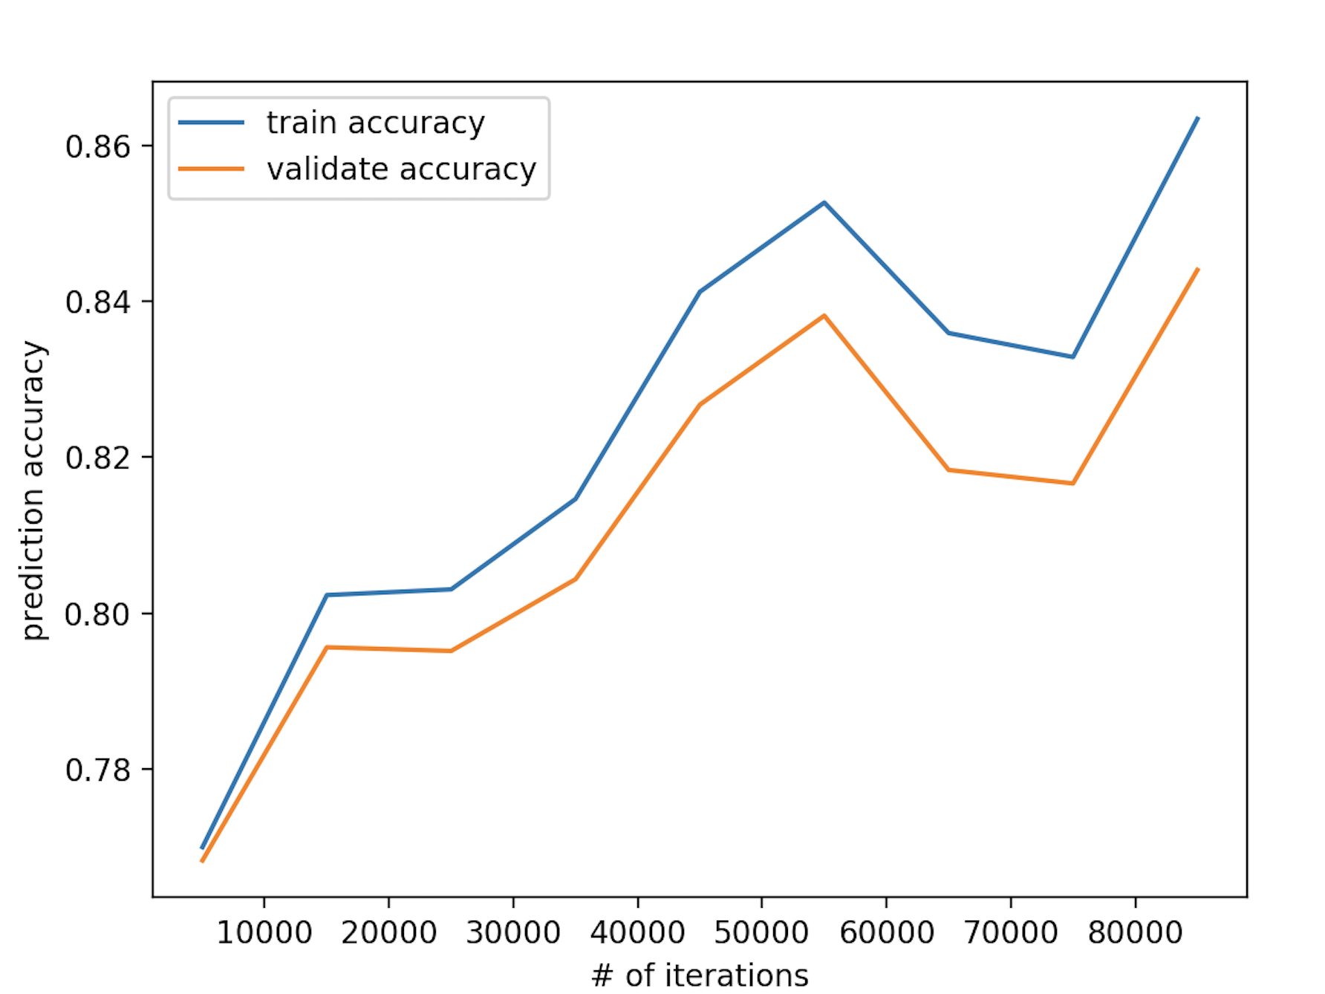

best iterations:85000 and max validation test accuracy:0.844019

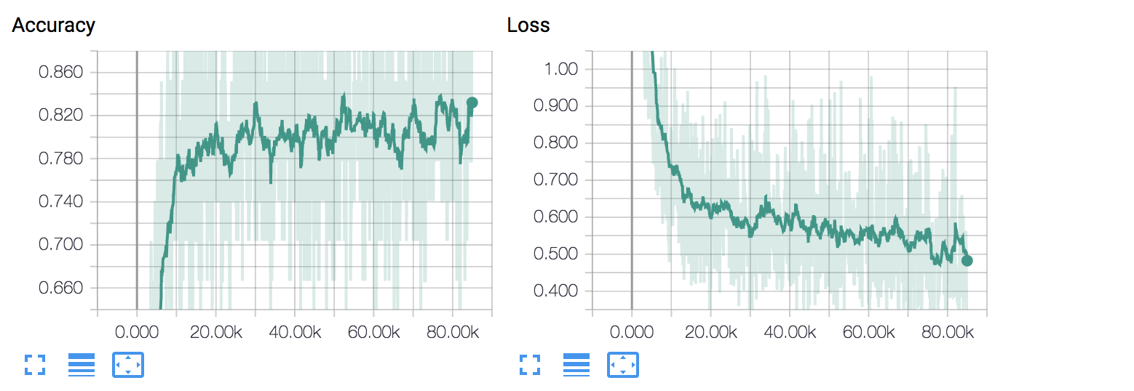

accuracy 0.9259 loss: 0.3034

whole train data accuracy:0.805433

whole test data accuracy:0.662824

2)iterations_set =np.arange(130000,150000,10000)

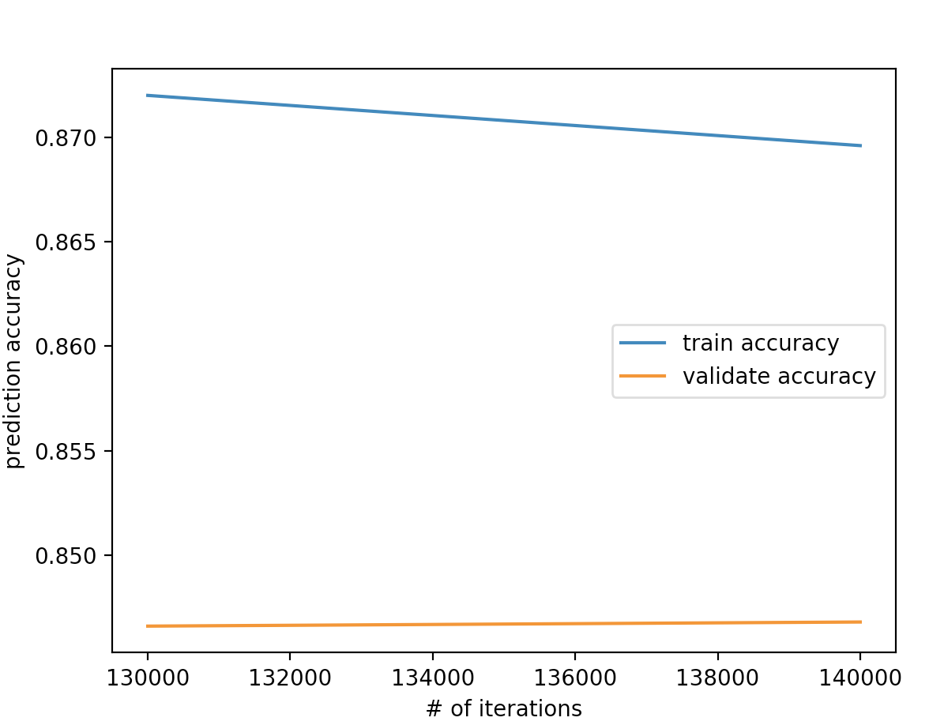

best iterations:140000 and max test accuracy:0.846811

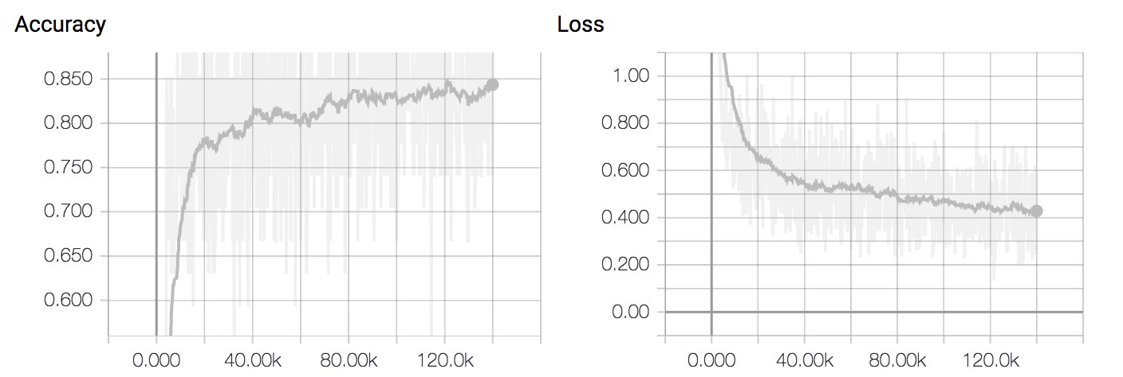

train accuracy= 0.9630 loss=0.2628

whole train data accuracy:0.829921

whole test data accuracy:0.627522

3) iteration =16000

whole train data accuracy:0.840315

whole test data accuracy:0.649135

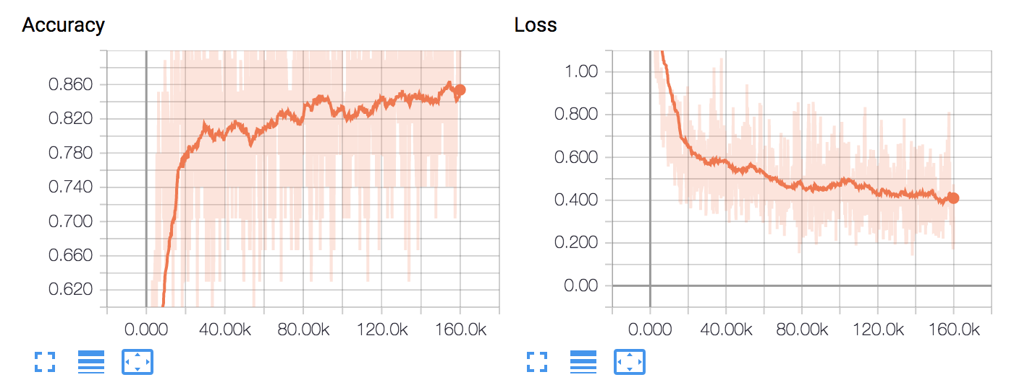

train accuracy= 0.9630 loss=0.1926

4) best_iterations=250000

whole train data accuracy:0.857638

whole test data accuracy:0.650576

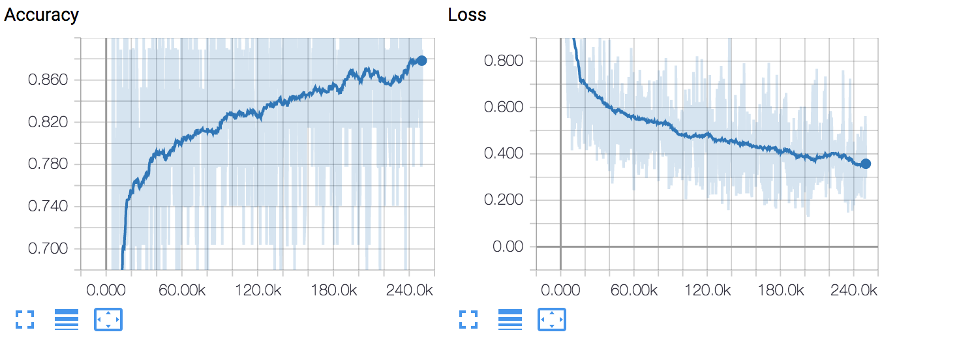

C. Smile-fiw dataset(<http://smile-fiw.weebly.com/download.html)-new> **2000 dataset**

**batchsize=27** #batch size must be even  
iterations =150000  
hiddenunit = 30  
ita = 0.5  
keep_pro = 0.75

whole train data accuracy:0.847857

whole test data accuracy:0.665706

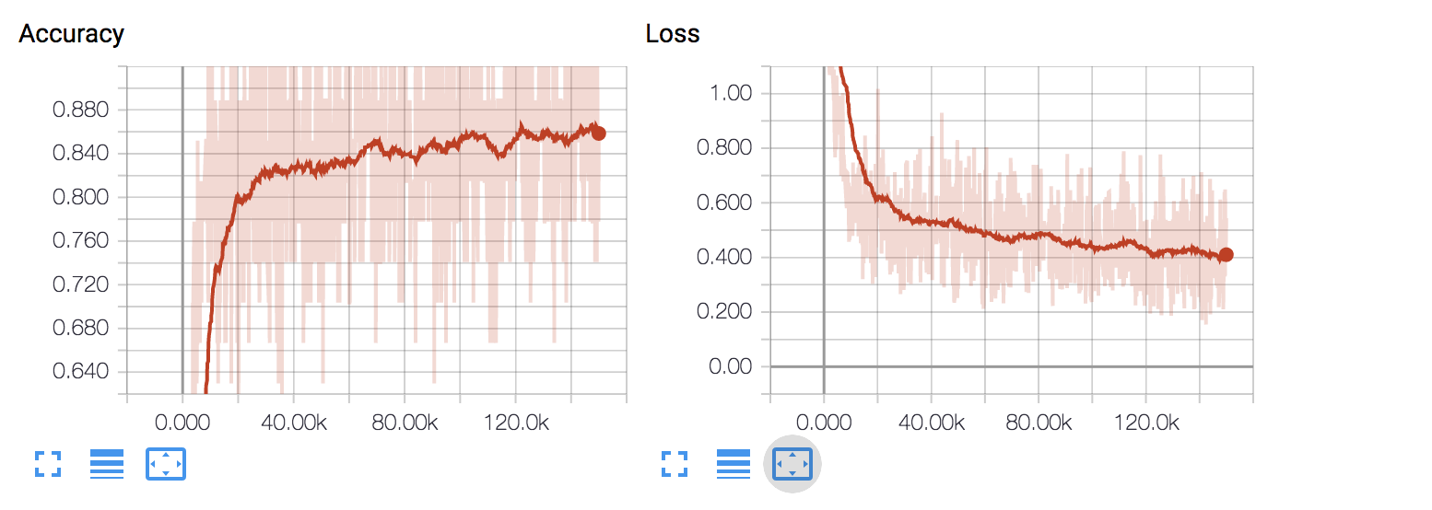

**batchsize=80 #**size must be even  
iterations =150000  
hiddenunit = 30  
ita = 0.5  
keep_pro = 0.75

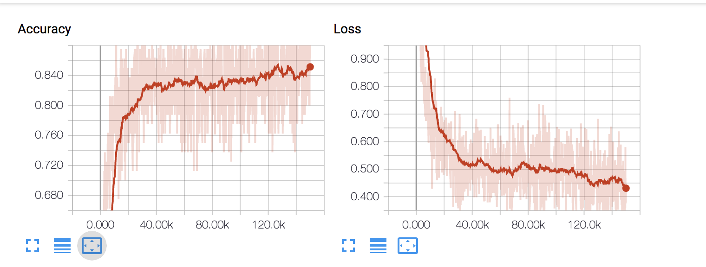

accuracy =0.86 and loss=0.41 at final state

whole train data accuracy:0.847638

whole test data accuracy:0.640576

**batchsize=40** #batch size must be even  
iterations =20000  
hiddenunit = 30  
ita = 0.5  
keep_pro = 0.75

train accuracy:0.800340,test accuracy :0.761225

train accuracy:0.820748,test accuracy :0.802041

train accuracy:0.833333,test accuracy :0.804082

train accuracy:0.838776,test accuracy :0.822449

train accuracy:0.838662,test accuracy :0.839796

train accuracy:0.855556,test accuracy :0.816327

train accuracy:0.853288,test accuracy :0.847959

train accuracy:0.864172,test accuracy :0.840816

train accuracy:0.863946,test accuracy :0.852041

train accuracy:0.873469,test accuracy :0.845918

best iterations:20000 and max test accuracy:0.823265

whole train data accuracy:0.823775

whole test data accuracy:0.66

========================================================

batchsize=40 #batch size must be even  
iterations =20000  
hiddenunit = 100  
ita = 0.5  
keep_pro = 0.75

whole train data accuracy:0.803775

whole test data accuracy:0.688761

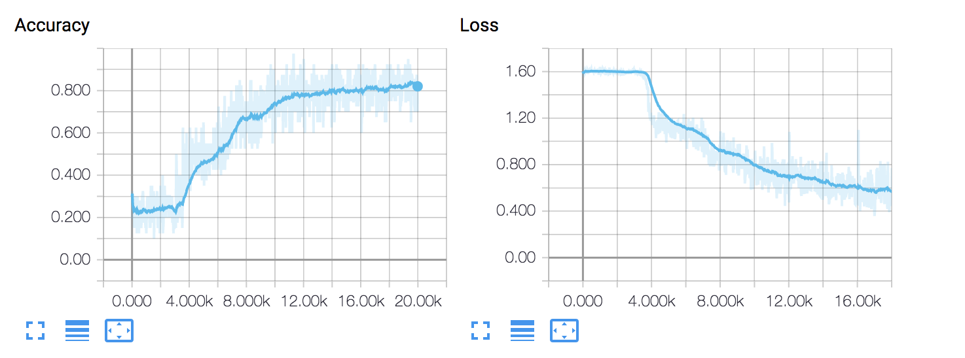

==================================================

batchsize=100

iteration =50000

hiddenunit = 80  
ita = 0.7  
keep_pro = 0.75

whole train data accuracy:0.979457

whole test data accuracy:0.698761

whole f-d test data accuracy:0.803226

whole f-s test data accuracy:0.596875

whole m-d test data accuracy:0.591065

whole m-s test data accuracy:0.628253

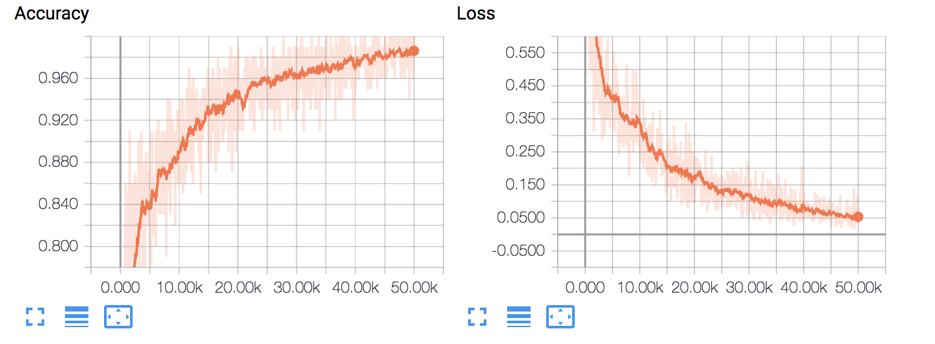

accuracy = 1.0 loss=0.03

# **Assume we have 4 cluster(previous is 5 clusters)---ignore useless**

batchsize=40 #batch size must be even  
iterations =20000  
hiddenunit = 100  
ita = 0.5  
keep_pro = 0.75

whole train data accuracy:0.741735

whole test data accuracy:0.716859

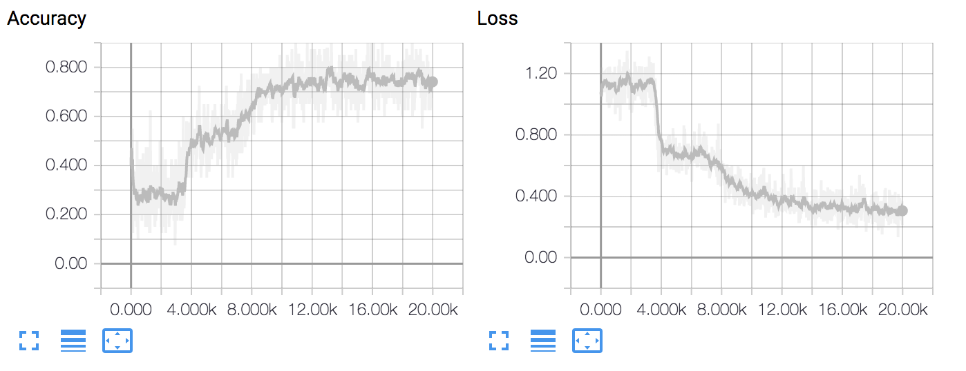

last state accuracy =0.80 loss=0.211

## **Assume we have 3 layers**

#relu  
#logistic  
#softmax

batchsize=60 #batch size must be even  
  
hiddenunit = 100  
ita = 0.5  
keep_pro = 0.75

iterations_set = np.arange(8000,32000,4000)

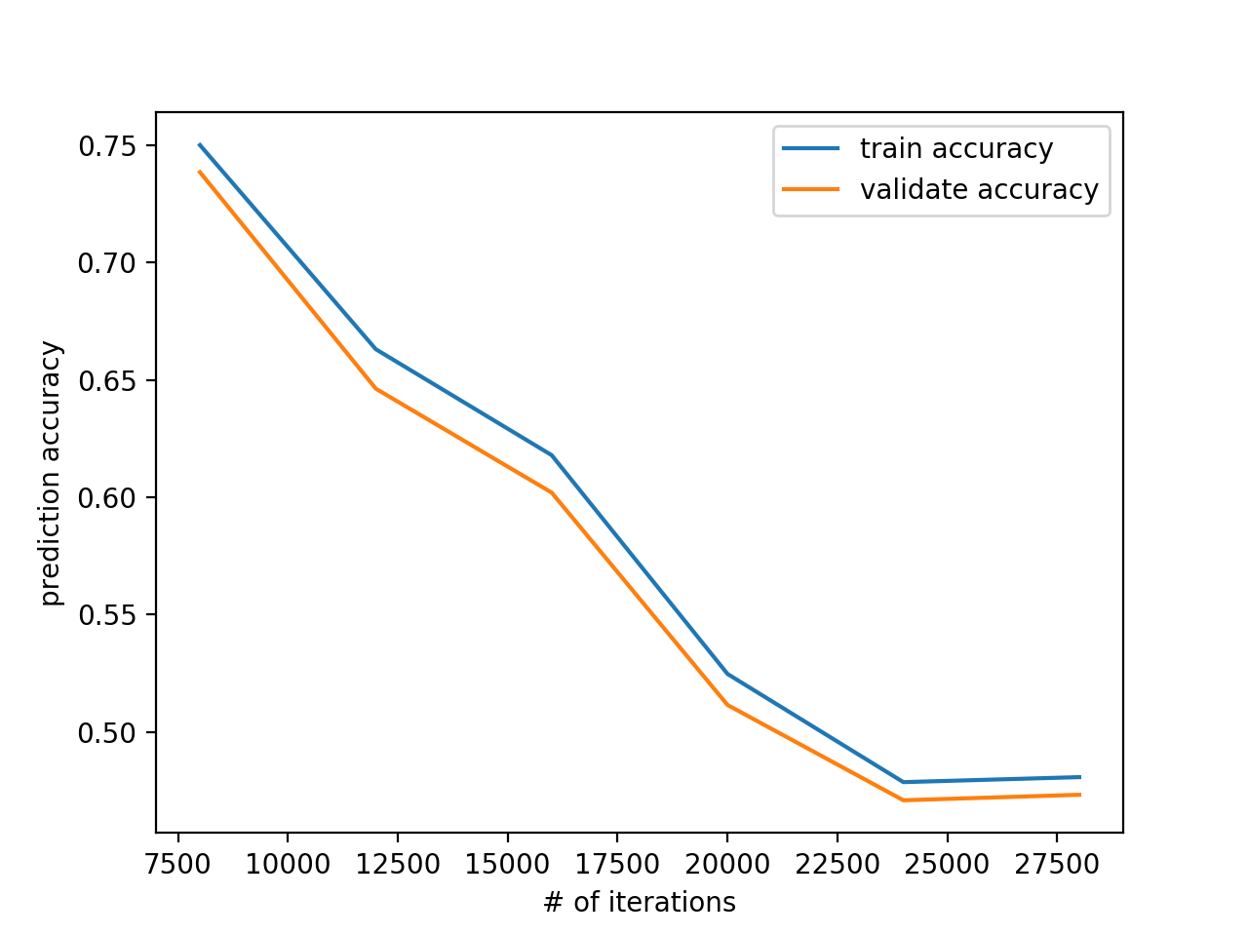

best iterations:8000 and max test accuracy:0.738469

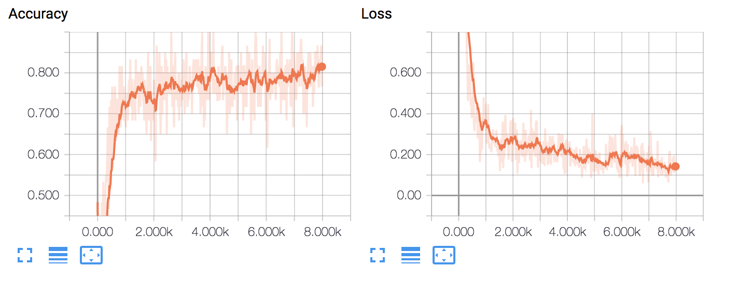

last state accuracy =0.8667 loss=0.1202

whole train data accuracy:0.792755

whole test data accuracy:0.695965

add more negative data

Change shuffle method

np.random.uniform(-1,0,1000)

change loss function as : cross_entropy -accuracy (since we found that the accuracy can not reach a good value,but the loss performs better )

ita hidden loss function(not that useful) btch size =100

batchsize=100 #batch size must be even  
best_iterations =50000  
hiddenunit = 80  
ita = 0.7  
keep_pro = 0.75

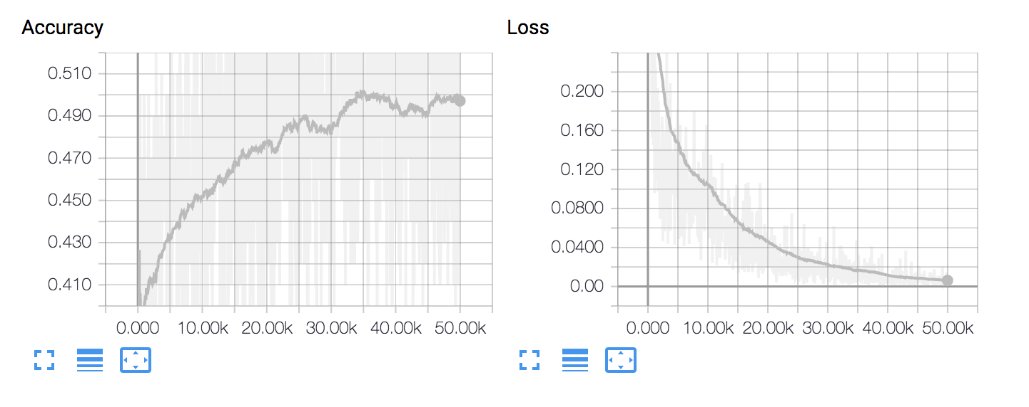

accuracy = 0.54 loss=0.004

whole train data accuracy:0.507865

whole f-d test data accuracy:0.832258

whole f-s test data accuracy:0.765625

whole m-d test data accuracy:0.776632

whole m-s test data accuracy:0.609665

**2. Two method :2 cluster combined with 4** cluster

A identification of relation

1. 2 cluster –3层

whole train data accuracy:0.973929

whole test data accuracy:0.760807

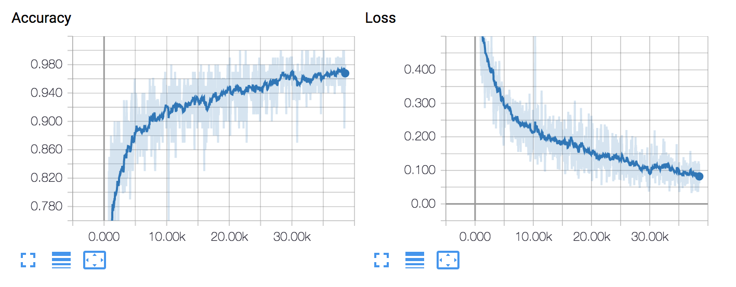

2. 2 cluster –1层logistics

iteration =10000

whole train data accuracy:0.844541

whole test data accuracy:0.798271

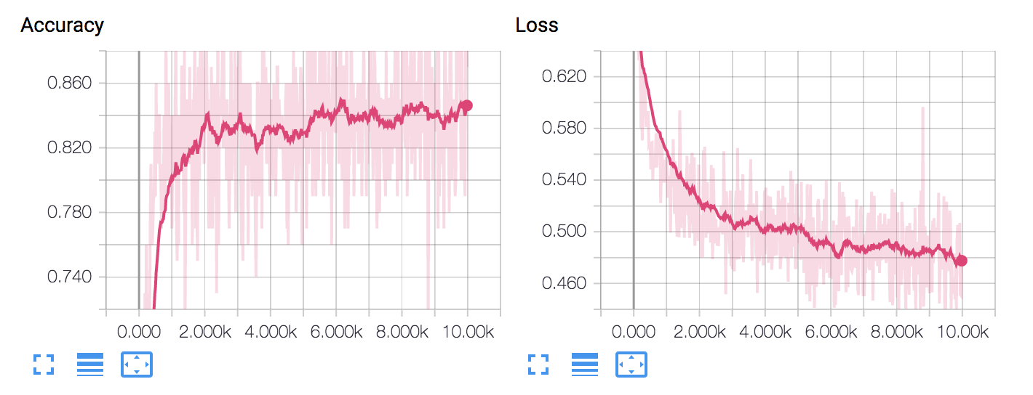

accuracy = 0.87 loss = 0.47

3. 2 cluster –sklearn

accuracy = 0.776657060519

B identification of kinship

Use all the positive data to train a model with 4 classifications

Use the data with relation from A get predicted result

Combine unrelated data from A and kinship from B

Get the final accuracy

batchsize=100 #batch size must be even  
best_iterations =10000  
hiddenunit = 80  
ita = 0.5  
keep_pro = 0.75

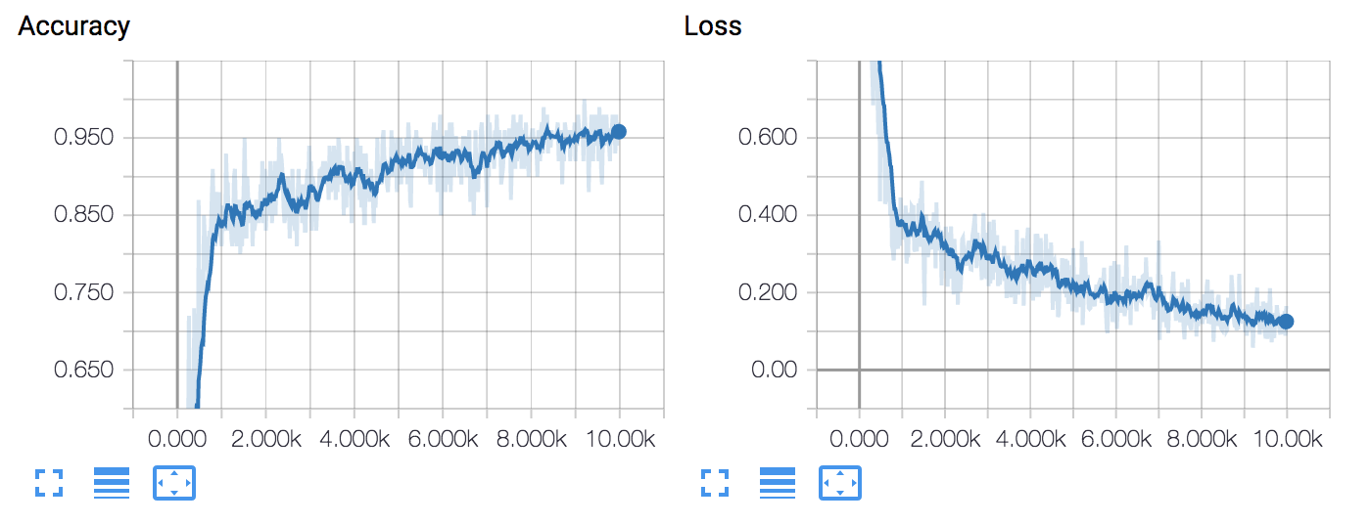

final state of 4 cluster(kinship:f-s f-d m-s m-d) training

accuracy: 0.9600 loss = 0.1625

whole train data accuracy:0.939500

whole test data accuracy:0.670029

whole f-d test data accuracy:0.732258

whole f-s test data accuracy:0.928125

whole m-d test data accuracy:0.659794

whole m-s test data accuracy:0.710037

whole kin test data accuracy:0.681250

test accuracy with 2 layer kinV:0.515130